Assignment 1 – Zadanie 1
(My perspectives 2, 1F, p.20)

Przygotuj prezentację wybranego przez siebie filmu trwającą dokładnie 60 sekund.
Pamiętaj, aby uwzględnić wszystkie zawarte w pkt 4, str. 20 elementy (tytuł, obsadę, wątek, rodzaj filmu, itp.)
Ważne abyś na koniec wypowiedzi wyraził swoje zdanie na jego temat. Czy go rekomendujesz czy nie? Koniecznie uzasadnij wypowiedź!

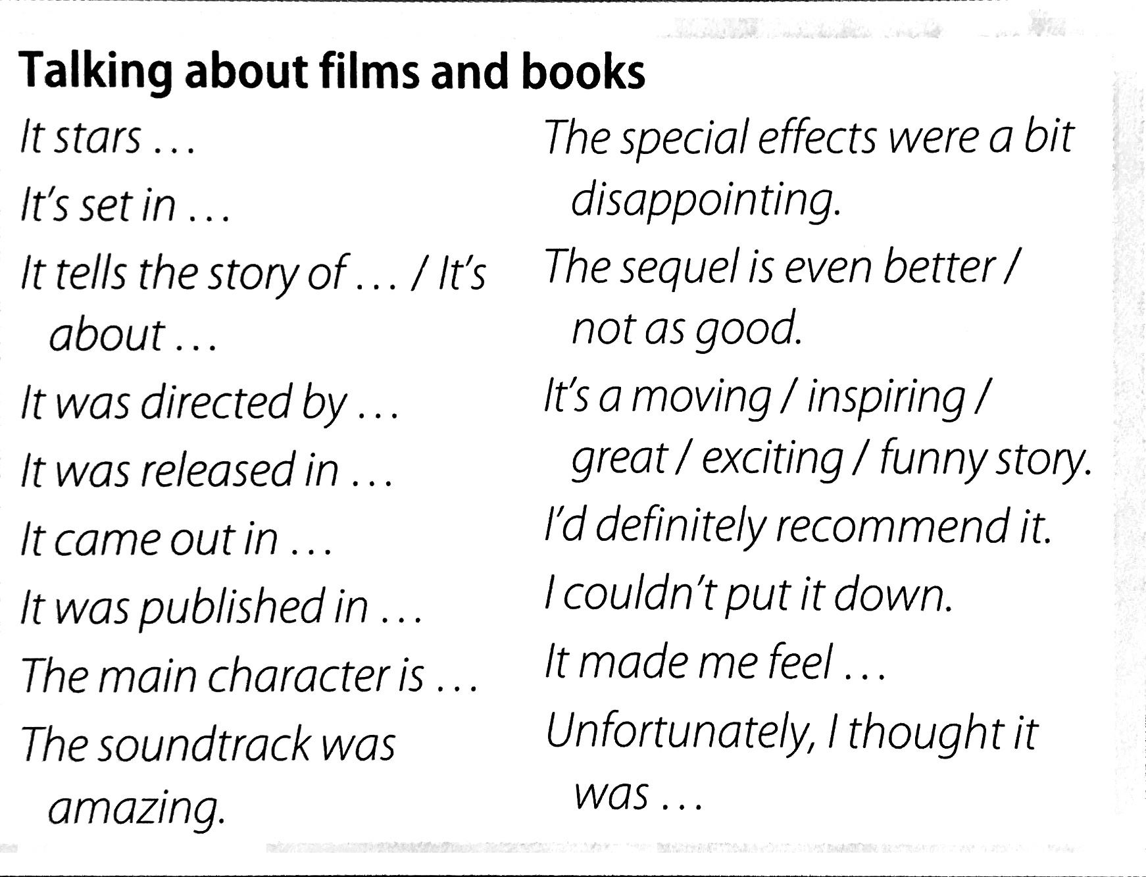
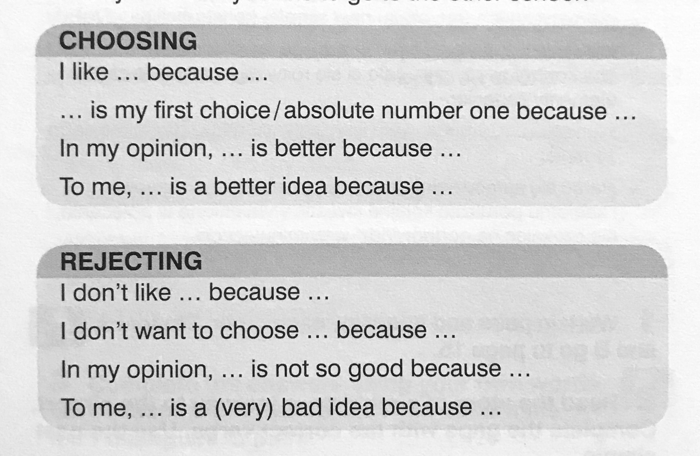

Ocenie podlegać będzie:
- Poprawność stylistyczna i gramatyczna.
- Użycie nowych konstrukcji (patrz Talking about films and books, Choosing, Rejecting)
- Forma prezentacji
- Właściwa reakcja na zadane przez Egzaminatora 😉 pytania:

Lista pytań:
- What is your favorite movie?
- Are there any kinds of movies you dislike?
- Do teenagers watch movies at home or at the cinema?
- Have you ever seen the same movie more than once?
- What kinds of movies are the most popular nowadays? (Why?)
- How often do you go to movies?
- What was the last movie you saw?
- What movie star would you most like to meet?
- What do you think of reality shows?
- Do you think that films can be educational?
- Is there a movie you could watch over and over again?
- Who's your favorite director?
- What do you think about film industry in Poland?
- Would you like to be an actor/actress? Why or why not?
- Do you think action movies are bad for children?
- Which do you prefer, to watch movies or to read books?
- Do you think historical movies are educational?
- Do you like documentaries?
- Do you watch trailers? (Why? Why not?)
- Do you like foreign films that are dubbed in your mother tongue or do you like watching the film in its original form?
- Do you think there is too much violence in movies? Does it affect children?
- Why do some people become famous and others don't?

Przydatne słownictwo znajdziesz tutaj:
https://quizlet.com/pl/380900086/matura-5-kultura-podstawa-flash-cards/

